Experiment 6

File Creation and Download Commands

Aim
To execute touch, pwd, and wget commands.

Theory

touch Command
Creates an empty file.
touch sample.txt

pwd Command
Displays current working directory.
Pwd

wget Command
Downloads files from the internet.
wget https://example.com/file.zip

Procedure
- Create a file using touch.
- Display current directory using pwd.
- Download a sample file using wget.

Output:
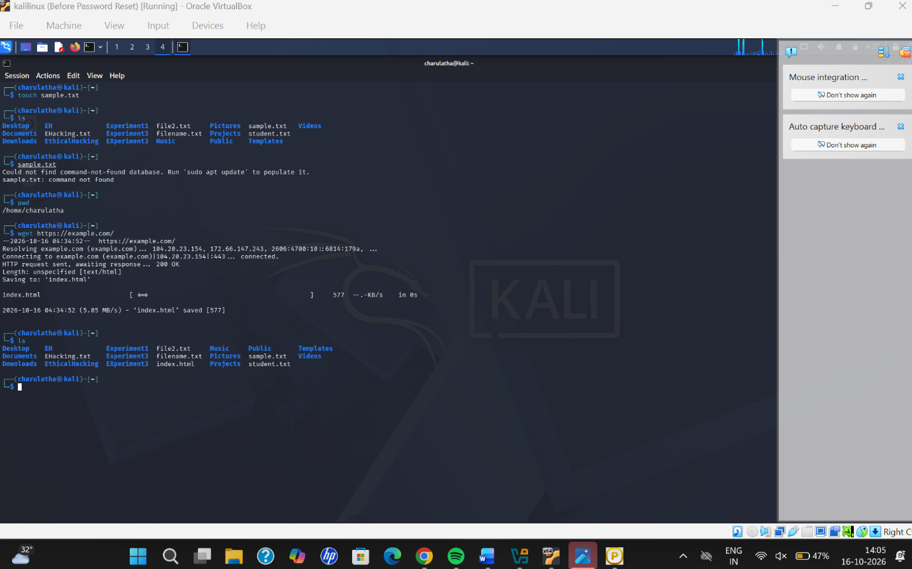

Result
Successfully executed touch, pwd, and wget commands.

